# **Name: Abdurrahman Qureshi**

# **Roll No: 242466**

Practical No: 7

1) Write a program to demonstrate the use of MYSQL Database using a MCQ application in java

ORIGINAL DATABSE TABLE

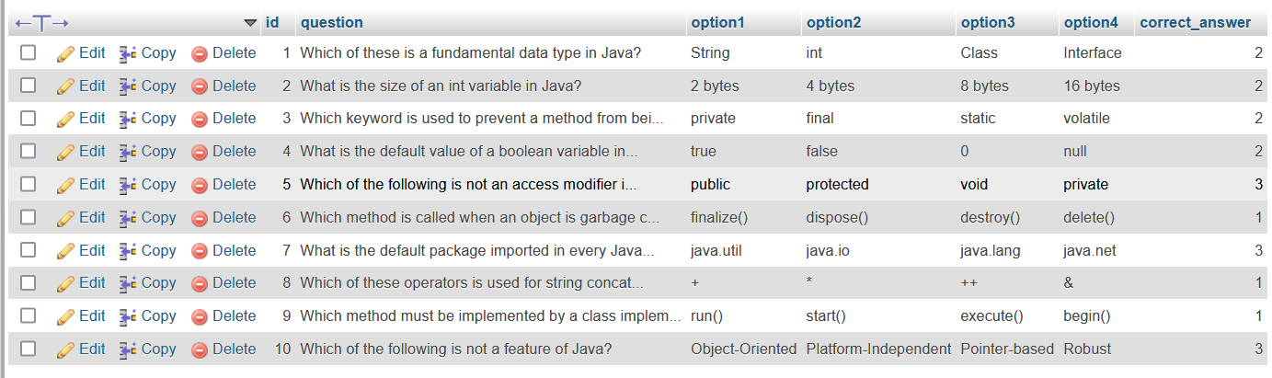

JAVA CODE

package mybankproject1;  
  
import javax.swing.*;  
import java.awt.*;  
import java.awt.event.ActionEvent;  
import java.awt.event.ActionListener;  
import java.sql.*;  
  
public class MainScreen extends JFrame {  
 private static final String *DB_URL* = "jdbc:mysql://localhost:3306/dbms"; private static final String *DB_USERNAME* = "root";

private static final String *DB_PASSWORD* = ""; private JLabel questionLabel;  
 private JRadioButton option1, option2, option3, option4;  
 private ButtonGroup optionsGroup;  
 private JButton nextButton;  
 private int currentQuestion = 0;  
 private ResultSet resultSet;  
 private Connection connection;  
 private int score = 0;  
 private int correctAnswer;  
  
 public MainScreen() {  
 setTitle("Java MCQ Test");  
 setSize(400, 300);  
 setDefaultCloseOperation(JFrame.*EXIT_ON_CLOSE*);  
 setLayout(new FlowLayout());  
  
 questionLabel = new JLabel("Question");  
 option1 = new JRadioButton("Option 1");  
 option2 = new JRadioButton("Option 2");  
 option3 = new JRadioButton("Option 3");  
 option4 = new JRadioButton("Option 4");  
  
 optionsGroup = new ButtonGroup();  
 optionsGroup.add(option1);  
 optionsGroup.add(option2);  
 optionsGroup.add(option3);  
 optionsGroup.add(option4);  
  
 nextButton = new JButton("Next");  
  
 add(questionLabel);  
 add(option1);  
 add(option2);  
 add(option3);  
 add(option4);  
 add(nextButton);  
  
 loadQuestion();  
 nextButton.addActionListener(new ActionListener() {  
 @Override  
 public void actionPerformed(ActionEvent e) {  
 checkAnswer();  
 loadNextQuestion();  
 }  
 });  
 }  
  
 private void loadQuestion() {  
 try {  
 if (resultSet == null) {  
 connection = DriverManager.*getConnection*(*DB_URL*, *DB_USERNAME*, *DB_PASSWORD*);  
 Statement statement = connection.createStatement();  
 resultSet = statement.executeQuery("SELECT * FROM mcq");  
 }  
  
 if (resultSet.next()) {  
 String question = resultSet.getString("question");  
 String opt1 = resultSet.getString("option1");  
 String opt2 = resultSet.getString("option2");  
 String opt3 = resultSet.getString("option3");  
 String opt4 = resultSet.getString("option4");  
 correctAnswer = resultSet.getInt("correct_answer");  
  
 questionLabel.setText(question);  
 option1.setText(opt1);  
 option2.setText(opt2);  
 option3.setText(opt3);  
 option4.setText(opt4);  
  
 optionsGroup.clearSelection();  
 } else {  
 showResult();  
 }  
  
 } catch (SQLException e) {  
 e.printStackTrace();  
 }  
 }  
  
 private void loadNextQuestion() {  
 currentQuestion++;  
 loadQuestion();  
 }  
  
 private void checkAnswer() {  
 int selectedOption = -1;  
 if (option1.isSelected()) {  
 selectedOption = 1;  
 } else if (option2.isSelected()) {  
 selectedOption = 2;  
 } else if (option3.isSelected()) {  
 selectedOption = 3;  
 } else if (option4.isSelected()) {  
 selectedOption = 4;  
 }  
  
 if (selectedOption == correctAnswer) {  
 score++;  
 }  
 }  
  
 private void showResult() {  
 JOptionPane.*showMessageDialog*(this, "Test completed! Your score: " + score);  
 try {  
 if (connection != null) {  
 connection.close();  
 }  
 } catch (SQLException e) {  
 e.printStackTrace();  
 }  
 System.*exit*(0);  
 }  
  
 public static void main(String[] args) {  
 SwingUtilities.*invokeLater*(() -> {  
 MainScreen frame = new MainScreen();  
 frame.setVisible(true);  
 });  
 }  
}

OUTPUT

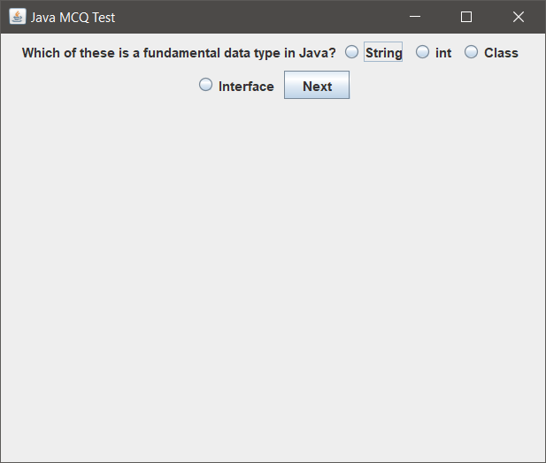 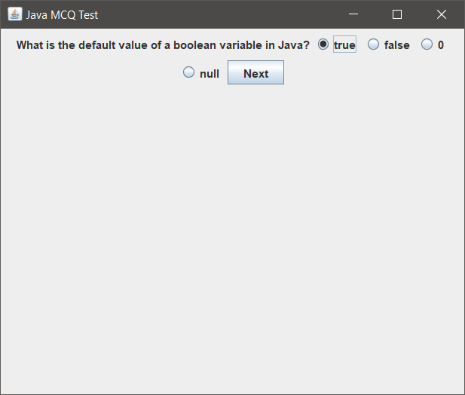

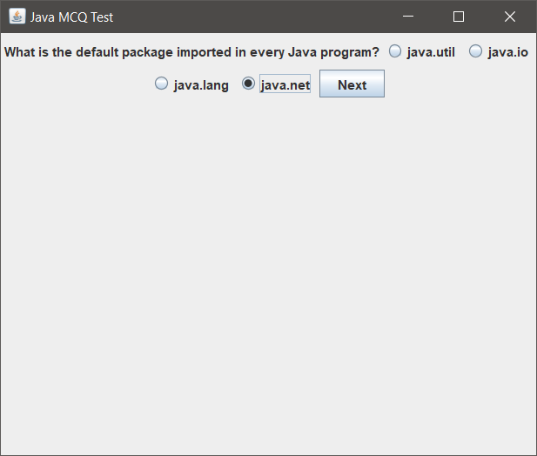 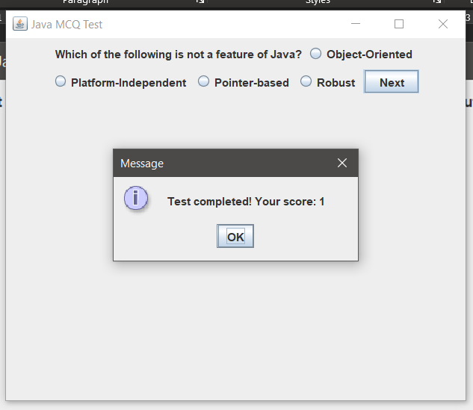

2) Write a program to demonstrate the use of MYSQL Database using a bank application in java

ORIGINAL DATABSE TABLE

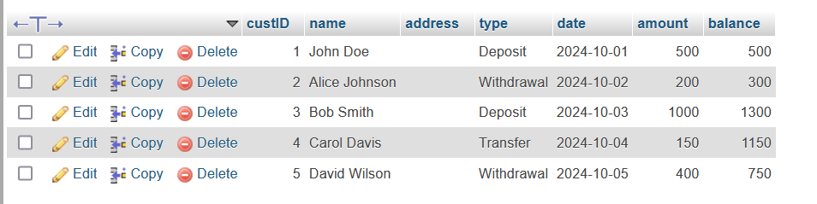

ADDING A CUSTOMER

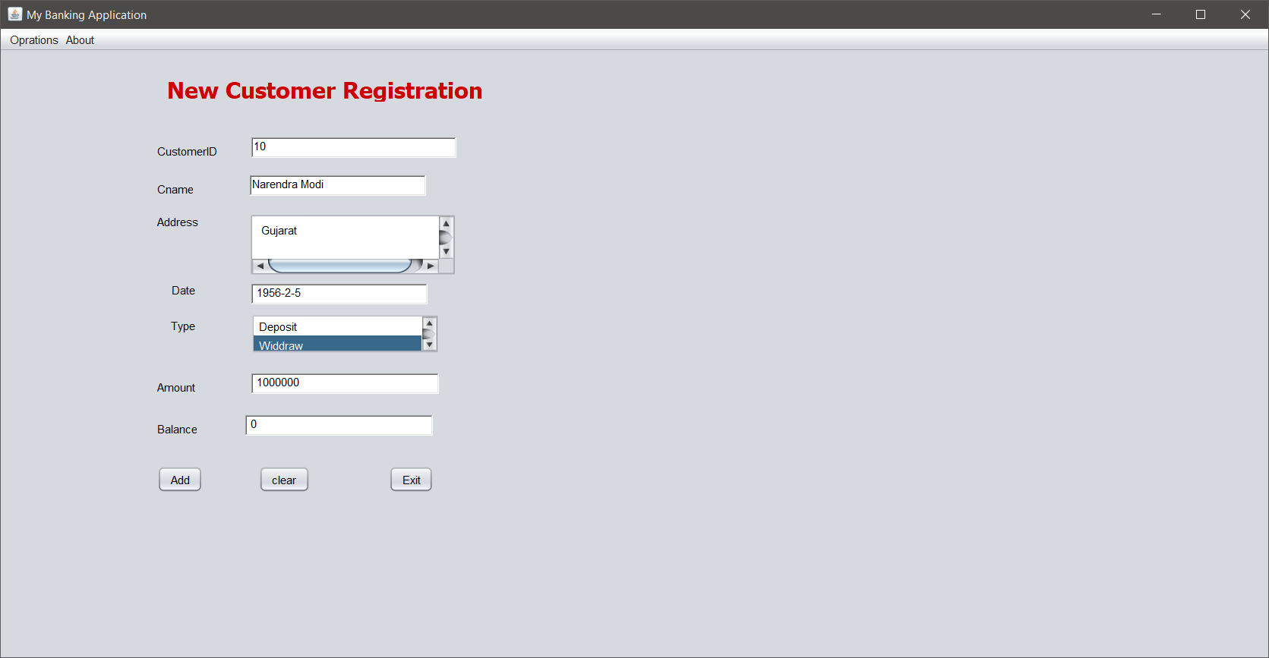

ADDING A CUSTOMER (CODE)

private void addCustomer(java.awt.event.ActionEvent evt)

try {  
 Class.*forName*("com.mysql.cj.jdbc.Driver");  
 Connection con = DriverManager.*getConnection*("jdbc:mysql://localhost:3306/dbms", "root", "");  
 PreparedStatement ps = con.prepareStatement("insert into bank values(?,?,?,?,?,?,?)");  
 ps.setInt(1, Integer.*parseInt*(txtid.getText()));  
 ps.setString(2, txtname.getText());  
 ps.setString(3, jTextArea1.getText());  
 ps.setString(4, txtdate.getText());  
 ps.setString(5, lsttype.getSelectedValue());  
 ps.setDouble(6, Double.*parseDouble*(txtamount.getText()));  
 ps.setDouble(7, Double.*parseDouble*(txtbalance.getText()));  
 ps.executeUpdate();  
  
  
 txtid.setText(" ");  
 txtname.setText(" ");  
 jTextArea1.setText(" ");  
 txtamount.setText(" ");  
 lsttype.clearSelection();  
 txtdate.setText(" ");  
 txtbalance.setText(" ");  
 txtid.requestFocus();  
  
  
 } catch (Exception e) {  
 e.printStackTrace();  
 }  
  
}

AFTER INSERTING TABLE

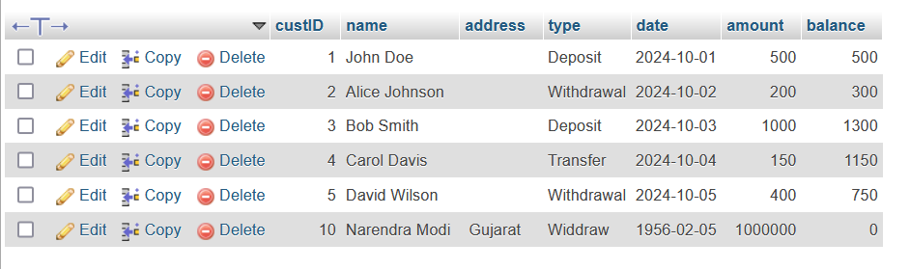

VIEWING CUSTOMERS (CODE)

private void cmdviewActionPerformed(java.awt.event.ActionEvent evt) {try {  
 Class.*forName*("com.mysql.cj.jdbc.Driver");  
 Connection con = DriverManager.*getConnection*("jdbc:mysql://localhost:3306/dbms", "root", "");  
 Statement stmt = con.createStatement();  
 ResultSet rs =  
 stmt.executeQuery("select * from bank where custid=" + txtcuid.getText());  
  
 DefaultTableModel dm = new DefaultTableModel(0, 0);  
 String[] header = new String[]{"CustId", "Name", "Address", "Date", "Type", "Amount", "Balance"};  
 dm.setColumnIdentifiers(header);  
 jTable1.setModel(dm);  
  
  
 while (rs.next()) {  
 int cid = rs.getInt(1);  
 String cname = rs.getString(2);  
 String caddress = rs.getString(3);  
 String cdate = rs.getString(4);  
 String ctype = rs.getString(5);  
 double camount = rs.getDouble(6);  
 double cbalance = rs.getDouble(7);  
  
 Vector<Object> data = new Vector<Object>();  
  
  
 data.add(cid);  
 data.add(cname);  
 data.add(caddress);  
 data.add(cdate);  
 data.add(ctype);  
 data.add(camount);  
 data.add(cbalance);  
 dm.addRow(data);  
}  
 } catch (Exception e) {  
 System.*out*.println(e.getMessage());  
 }  
  
  
 }

private void cmdviewallActionPerformed(java.awt.event.ActionEvent evt) {try {  
 Class.*forName*("com.mysql.jdbc.Driver");  
 Connection con = DriverManager.*getConnection*("jdbc:mysql://localhost:3306/dbms", "root", "");  
 Statement stmt = con.createStatement();  
 ResultSet rs = stmt.executeQuery("select * from bank");  
  
 DefaultTableModel dm = new DefaultTableModel(0, 0);  
 String[] header = new String[]{"CustId", "Name", "Address", "CDate", "Type", "Amount", "Balance"};  
 dm.setColumnIdentifiers(header);  
 jTable1.setModel(dm);  
  
  
 while (rs.next()) {  
 int cid = rs.getInt(1);  
 String cname = rs.getString(2);  
 String caddress = rs.getString(3);  
 String cdate = rs.getString(4);  
 String ctype = rs.getString(5);  
 double camount = rs.getDouble(6);  
 double cbalance = rs.getDouble(7);  
  
 Vector<Object> data = new Vector<Object>();  
  
  
 data.add(cid);  
 data.add(cname);  
 data.add(caddress);  
 data.add(cdate);  
 data.add(ctype);  
 data.add(camount);  
 data.add(cbalance);  
 dm.addRow(data);  
  
}  
 } catch (Exception e) {  
 System.*out*.println(e.getMessage());  
 }  
  
 }private void jButton1ActionPerformed(java.awt.event.ActionEvent evt) {txtcuid.setText("");  
  
 DefaultTableModel model = (DefaultTableModel) jTable1.getModel();  
 model.setRowCount(0);  
  
 }

VIEWING CUSTOMERS

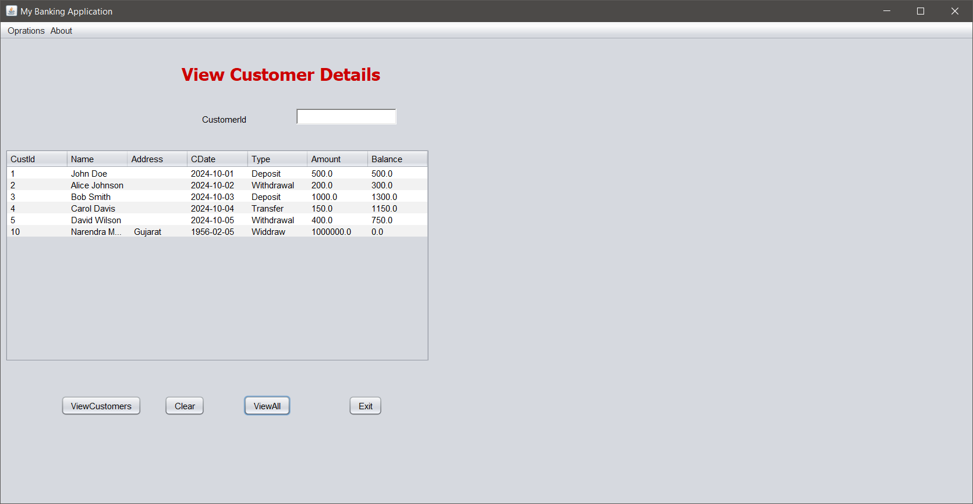

VIEWING CUSTOMER WITH ID 2

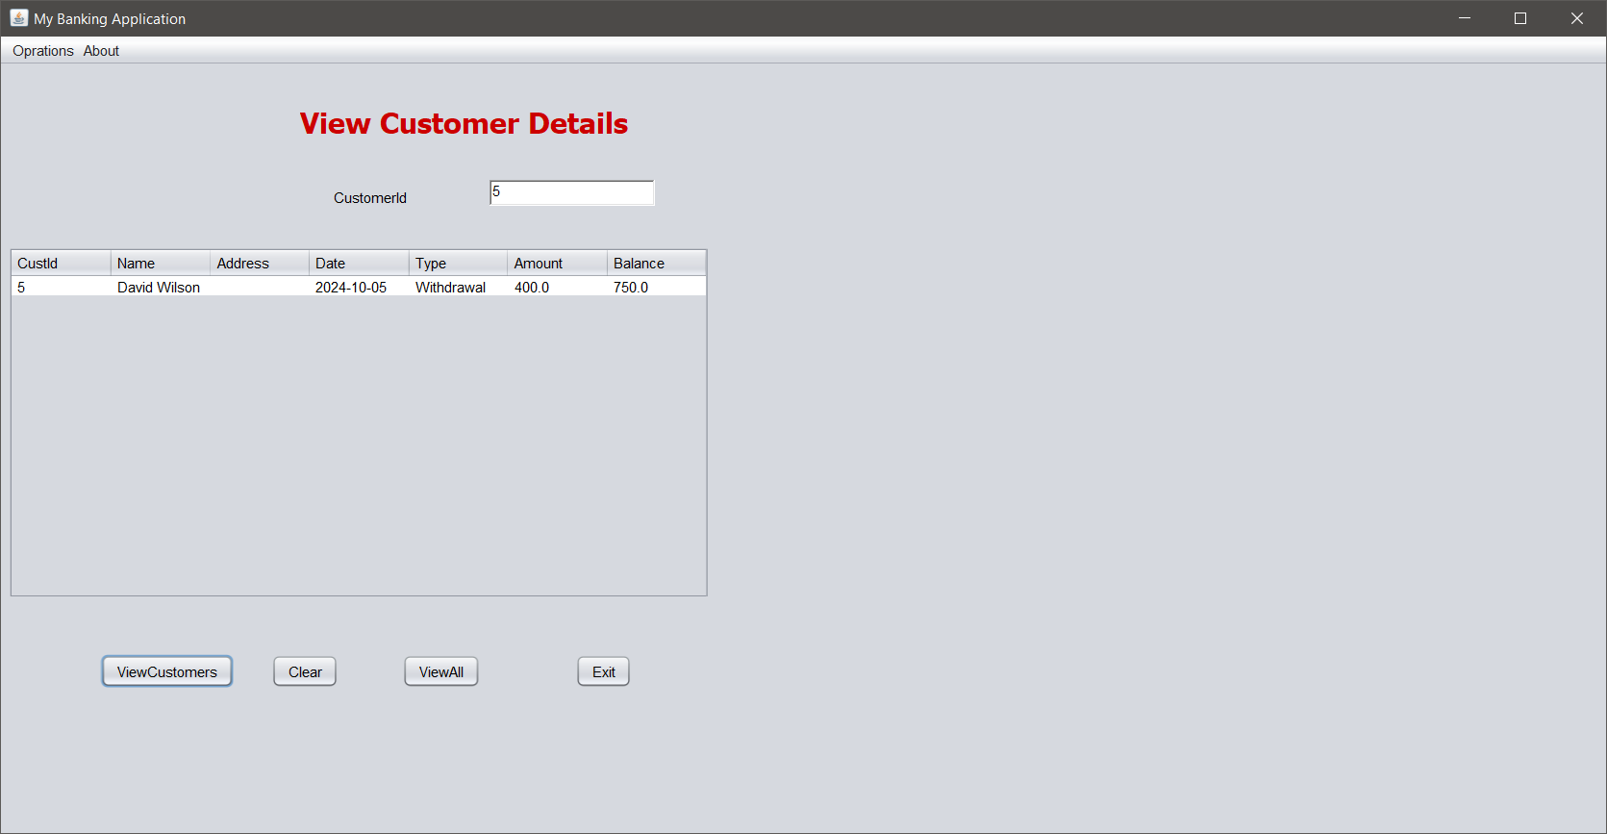

VIEWING CUSTOMERS’S BALANCE

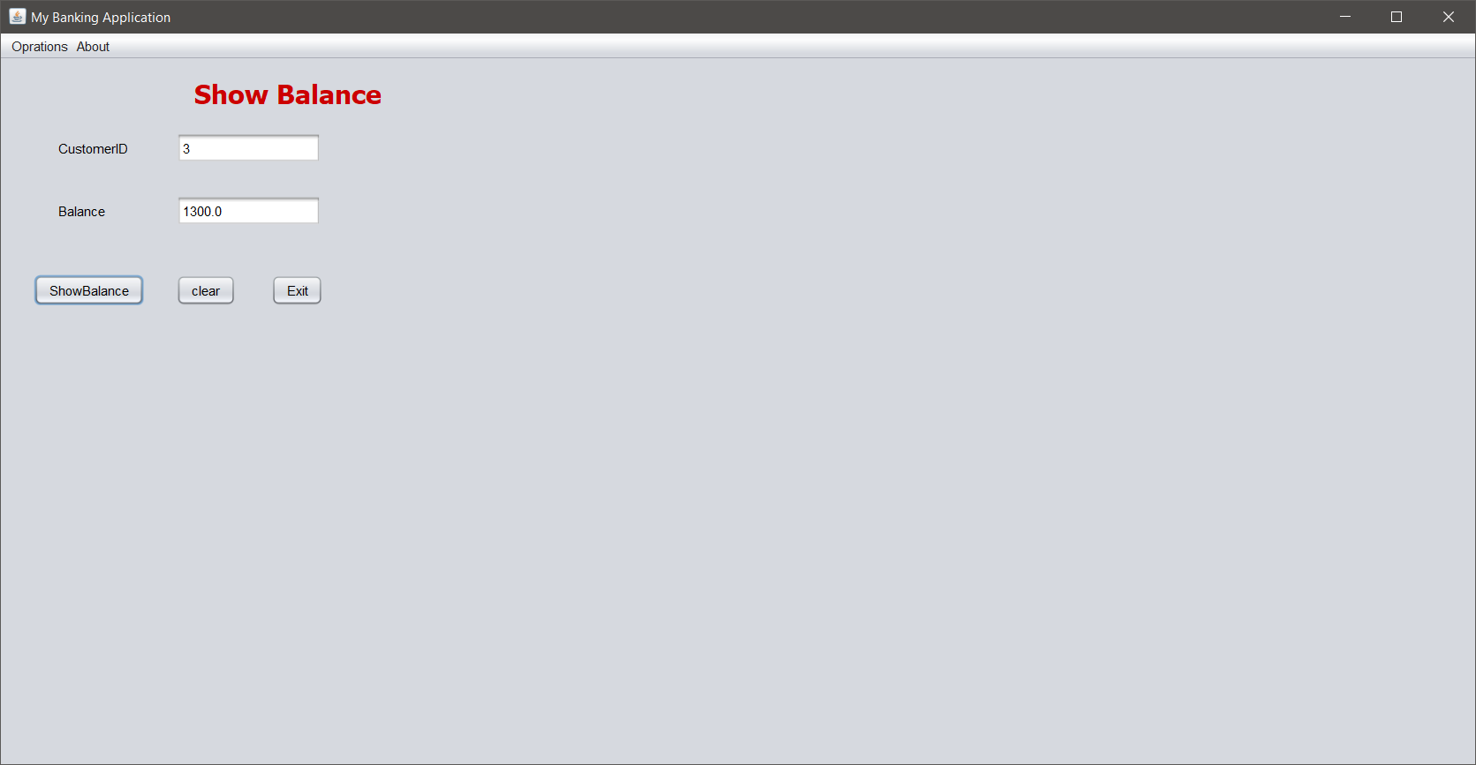

VIEWING CUSTOMERS’S BALANCE (CODE)

private void jButton1ActionPerformed(java.awt.event.ActionEvent evt) {try {  
 Class.*forName*("com.mysql.jdbc.Driver");  
 Connection con = DriverManager.*getConnection*("jdbc:mysql://localhost:3306/dbms", "root", "");  
 Statement stmt = con.createStatement();  
 ResultSet rs =  
 stmt.executeQuery("select * from bank where custid=" + txtcuid.getText());  
 double cbalance = 0;  
 while (rs.next()) {  
 cbalance = rs.getDouble(7);  
 }  
 txtbal.setText("" + cbalance);  
  
 } catch (Exception e) {  
 e.printStackTrace();  
 }  
  
}